Alexander Baldree
04/14/2026
Module 5.2 Assignment
CSD420

GitHub Link:
https://github.com/Panda-Alex21687/CSD420

MVN Java Execute:
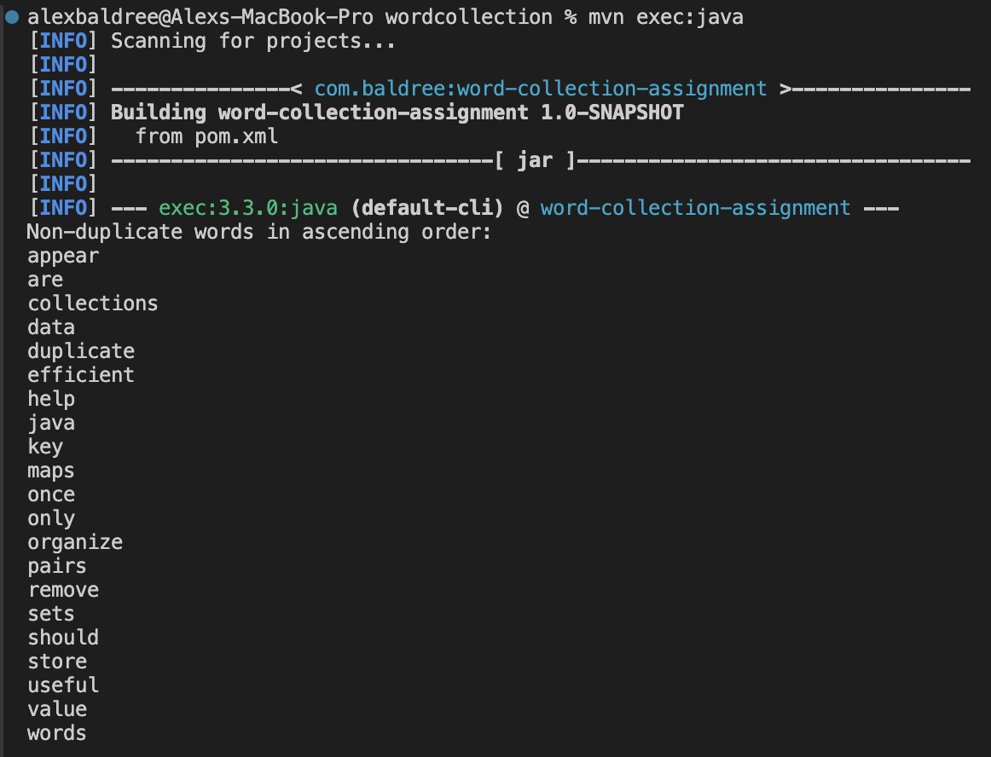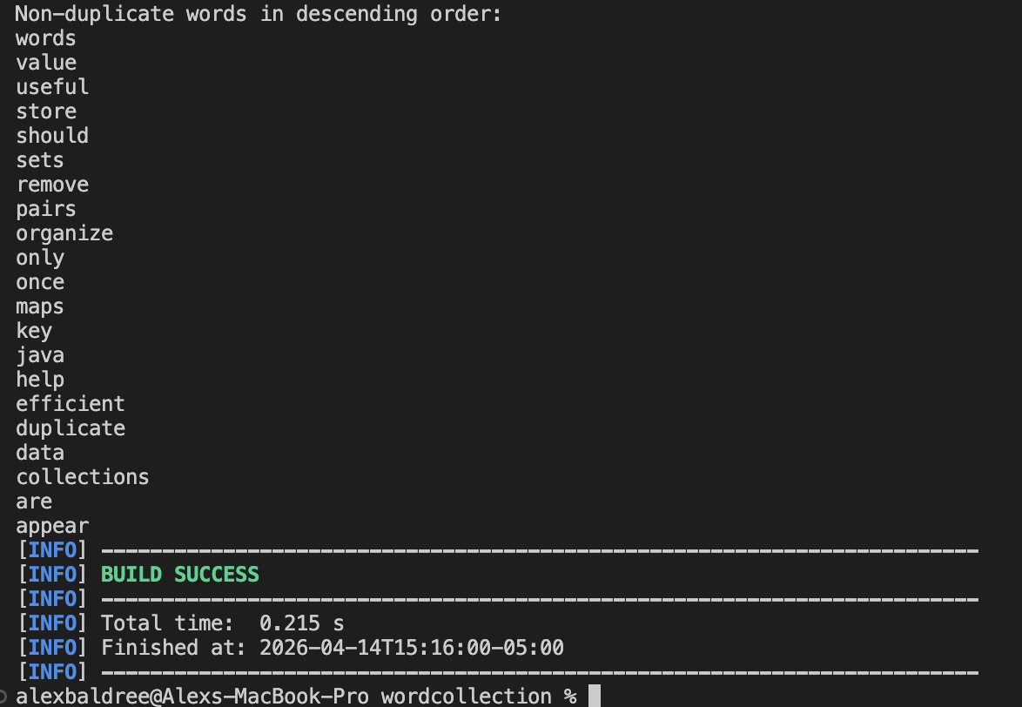

Maven Library:
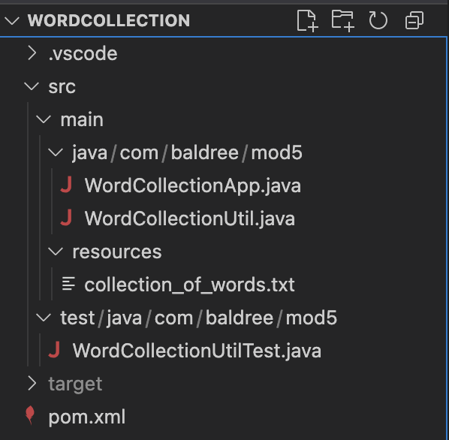

Maven Library Setup/Install:
